BYQ35kVA Hipot Tester

User Manual

Wuhan Lvnengde Precision Testing Technology Co., Ltd

Safety Rules and Precautions

Thank you for purchasing our company's Induced Voltage Withstand Test Set. To help you become proficient in using the instrument as soon as possible, please read this user manual carefully.

- The purpose of this manual is to familiarize users with, safely, correctly, and effectively operating and using it.

- Following these instructions will help prevent danger, reduce repair costs, and prevent instrument malfunctions caused by abnormal operations. In addition, it can ensure the reliable operation and service life of the tester.

- The use of the tester must comply with all safety requirements stipulated in the relevant standards for accident prevention and environmental protection.

- Simply reading the user manual of the tester does not exempt you from complying with all relevant national and international safety regulations.

- The user manual must be available at all times during the use of the tester. All users who use and test the equipment must read it.

- In addition to complying with the user manual and some national and local safety regulations to prevent accidents, attention should also be paid to recognized technical processes for safe and appropriate work. Safety rules to ensure one's own safety.

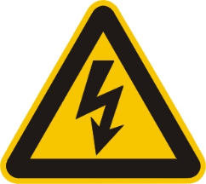
- Please comply with the safety regulations for preventive testing of safety tools in the national power industry, and do not operate in harsh environments such as flammable, explosive, and humid environments; Emphasize behaviors or guidance that pose potential risks to the body and life. Only qualified personnel are allowed to operate, and extreme caution and attention to safety regulations are required.

- Do not disassemble the instrument without the permission of our company. If the instrument malfunctions due to unauthorized disassembly, no warranty or return will be provided. If personal or property injury is caused as a result, our company will not be held responsible.

- To ensure continuous improvement and perfection of product functionality, the specifications of this instrument may be updated periodically. Therefore, there may be slight differences between the instrument you are using and the instruction manual, which will not be notified separately. If you have any questions, please call our after-sales department or visit our website for more information.

- Carefully ensure
For products manufactured by our company, we guarantee replacement within one month from the date of shipment if defects are found. Free repairs are provided within one year (inclusive) if defects occur. For defects found beyond one year, we offer paid lifetime repairs.
- Safety requirements
Please read the following safety precautions to avoid personal injury and prevent damage to this product or any other products connected to it. To avoid potential hazards, this product can only be used within the specified range.

Only qualified technicians can perform repairs.

- —Prevent fire or personal injury
Use appropriate power cords. Only use power cords that are specific to this product and meet its specifications.
Connect and disconnect correctly. When connecting the test wire to the live terminal, do not connect or disconnect the test wire at will.
Product grounding. This product must be grounded through the grounding wire of the power cord, and the grounding column of the product casing must also be grounded. To prevent electric shock, the grounding conductor must be connected to the ground. Before connecting to the input or output terminals of this product, ensure that the product is properly grounded.
Pay attention to the rated values of all terminals. To prevent fire or electric shock hazards, please pay attention to all ratings and markings of this product. Before connecting this product, please read the user manual for further information on the rated values.
·Do not operate without an instrument cover. Do not operate this product if the cover or panel has been removed.
·Use appropriate fuses. Only fuses that meet the specified type and rating of this product can be used.
·Avoid contact with exposed circuits and live metal.Do not touch exposed contacts and parts when the product is powered on.
·Do not operate when there is a suspicious malfunction. If you suspect that this product is damaged, please have our maintenance personnel inspect it and do not continue to operate it.

Do not operate in damp environments.
Do not operate in explosive environments.
Keep the surface of the product clean and dry.

SECURITY
Warning: Warning words indicate situations or practices that may cause personal injury or death.
Caution: Use caution to indicate situations or practices that may cause damage to this product.

Content

- Overview--------------------------------------------------------------2
- Structure-------------------------------------------------------------2
- Model meaning-----------------------------------------------------3
- Working Principle---------------------------------------------------3
- Control circuit diagram----------------------------------------------4
- Test site layout ------------------------------------------------------6
- Operation test method---------------------------------------------7
- Precautions--------------------------------------------------------8
- Maintenance and upkeep-------------------------------------------8
- The usage conditions of the test transformer---------------------10
- Technical indicators and parameters-----------------------------11

- Overview
Test transformers are essential testing equipment for the detection and preventive testing of power equipment. With the development of China's power industry, the voltage level requirements for test transformers are becoming increasingly high, and traditional oil immersed test transformers are increasingly unable to meet the requirements of on-site work in terms of volume, weight, and performance.

With the progress of basic scientific research in China and the application of new materials and processes, the new medium sulfur hexafluoride gas has been pushed into the field of power equipment applications. Due to its excellent insulation performance, arc extinguishing ability, and non flammability, sulfur hexafluoride gas has been widely used as a new insulation medium.

After years of effort, our company has successfully developed an inflatable lightweight test transformer. Compared with traditional oil immersed lightweight test transformers, this series of products reduces weight by 20% -60% (depending on voltage and capacity level), and has no oil pollution. The voltage level of a single test transformer can reach 300KV. Due to the use of new production processes, the technical performance of the products has been greatly improved, making them particularly suitable for on-site work and frequent mobile working conditions

- Structure
1. The design concept, material selection, and process flow of BYQ series products are all brand new, so they are not only small in size, light in weight, and beautiful in appearance, but also meet the technical indicators required by JB3570-98 standards.
The BYQ series products use high-quality cold-rolled DQ-151 oriented silicon steel sheets stacked into multi-stage cylindrical frame shaped iron cores, which are directly and continuously wound with QZ type wires on a specially designed high-strength insulation cylinder to form high-voltage tower coils. The outer shell is cylindrical and filled with SF6 gas.
2. The difference between BYQ (JZ) products and BYQ products lies in the clever installation of a high-voltage rectifier silicon stack inside a high-voltage sleeve, which can be converted into a power frequency high-voltage AC output or a high-voltage DC output through the insertion and extraction of a short-circuit rod.

- Model meaning

B Y Q （C）
Rated output voltage KV
Rated capacity
Cascade
inflatable
single-phase
Test Transformer

- Working Principle
The control panel (box) with overcurrent automatic tripping and zero position interlocking device to prevent sudden pressurization is used to input the power supply. The voltage is regulated by an autotransformer and input into the primary winding of the BYQ test transformer. According to the principle of electromagnetic induction, the secondary (high voltage) winding can obtain the same multiple of voltage amplitude - power frequency high voltage - based on its ratio to the number of turns of the primary winding. This power frequency high voltage can be rectified by a high voltage silicon stack and filtered by a stabilizing capacitor to obtain a direct current high voltage, with an amplitude √ 2 times the effective value of the power frequency high voltage.

- Control circuit diagram
The circuit diagram of the ordinary console (box) is as follows:
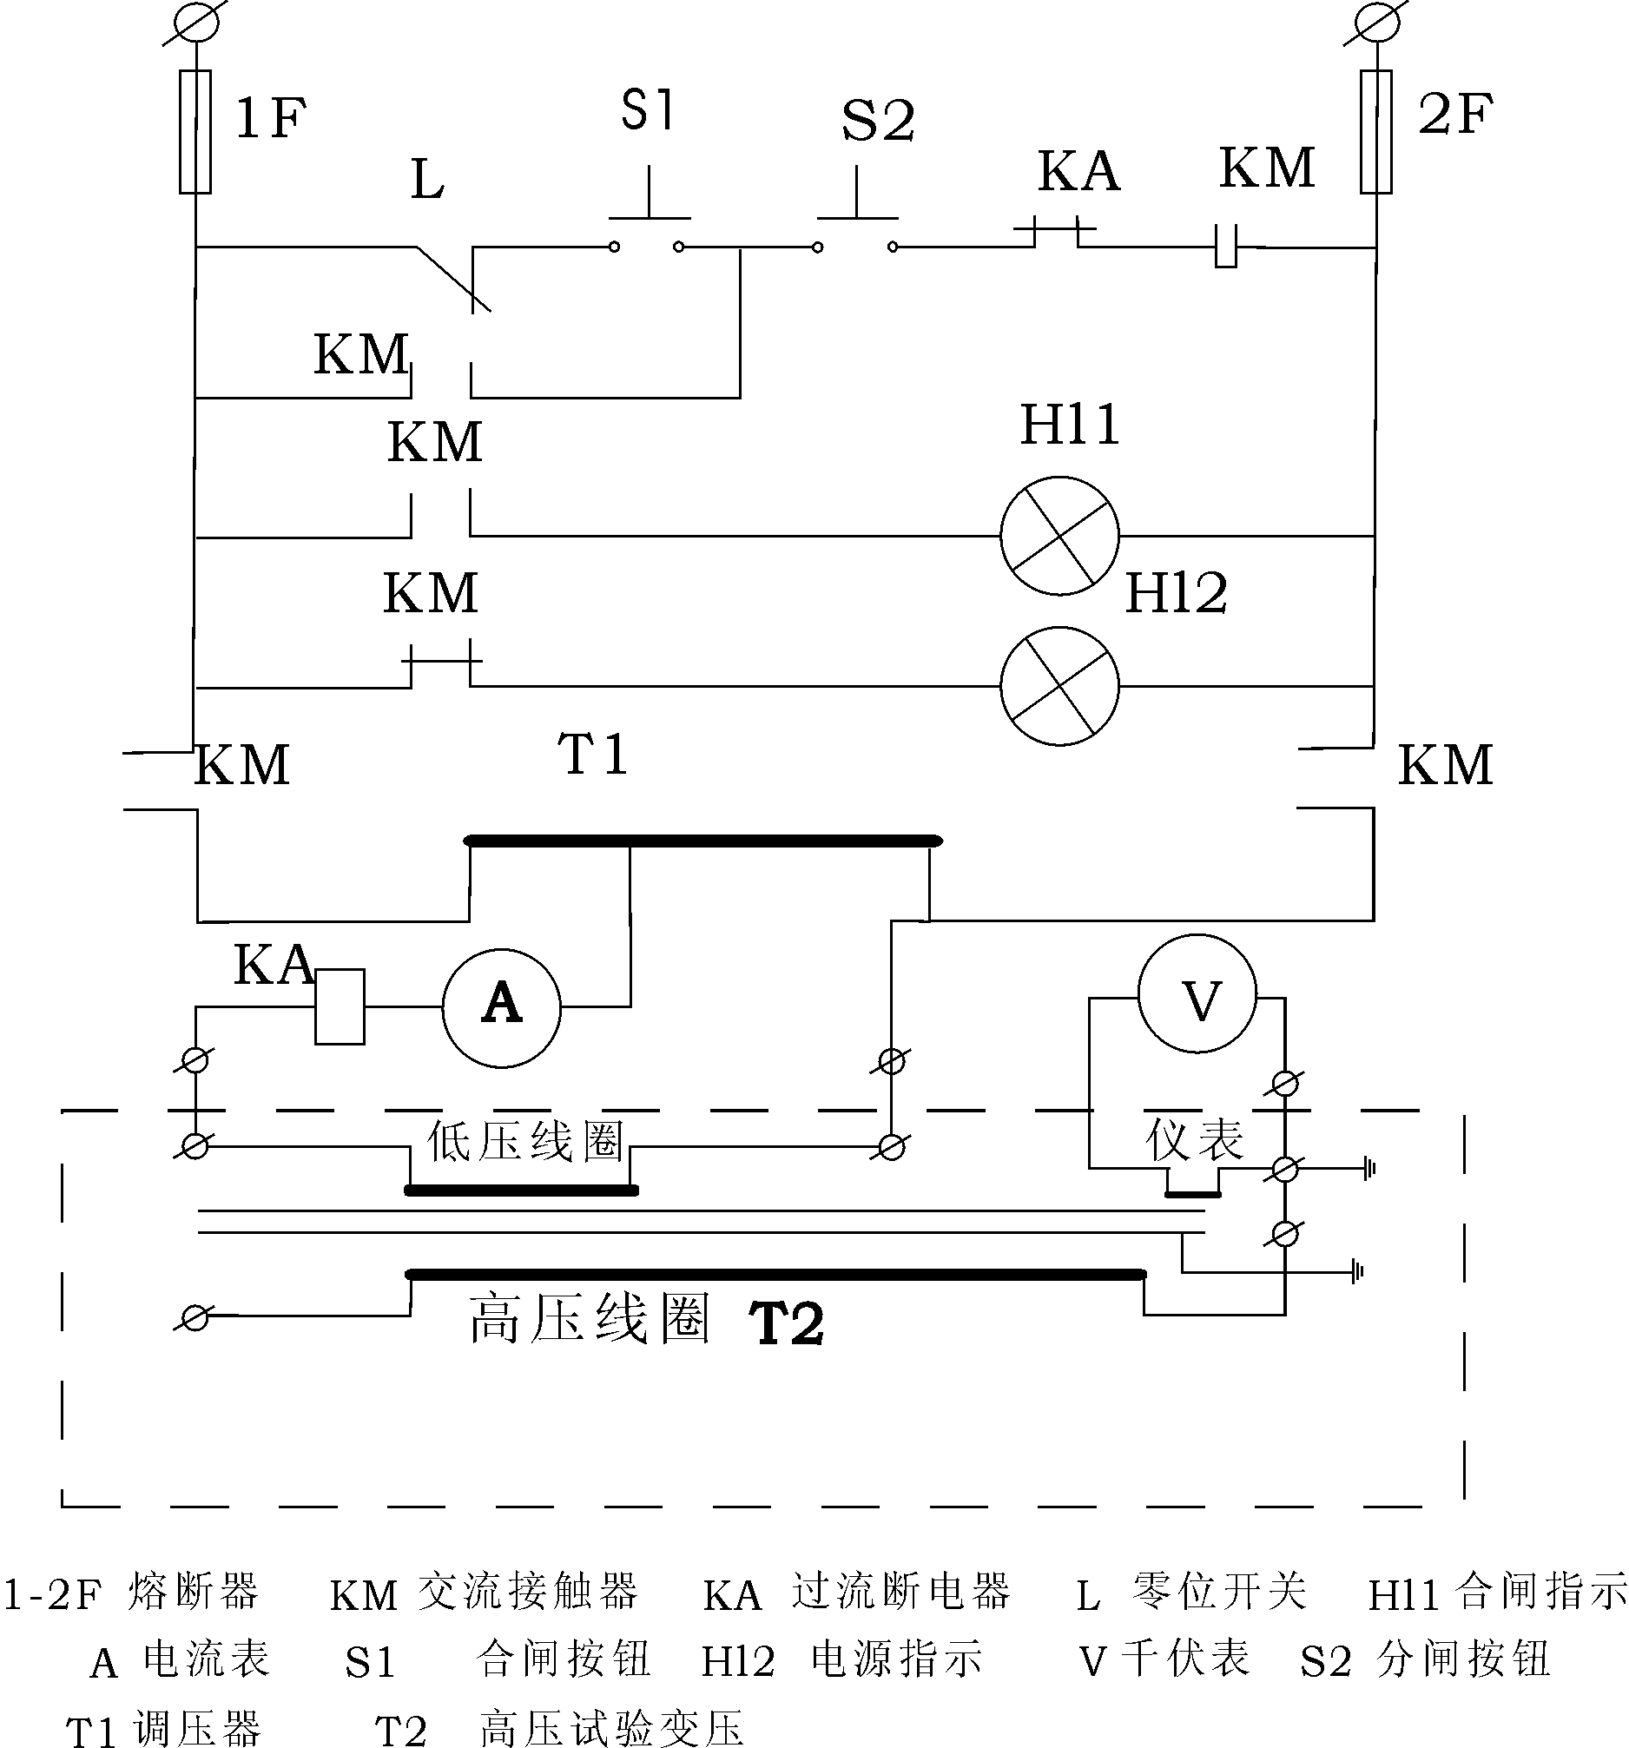

- Test site layout
1. Wiring diagram for AC voltage withstand test
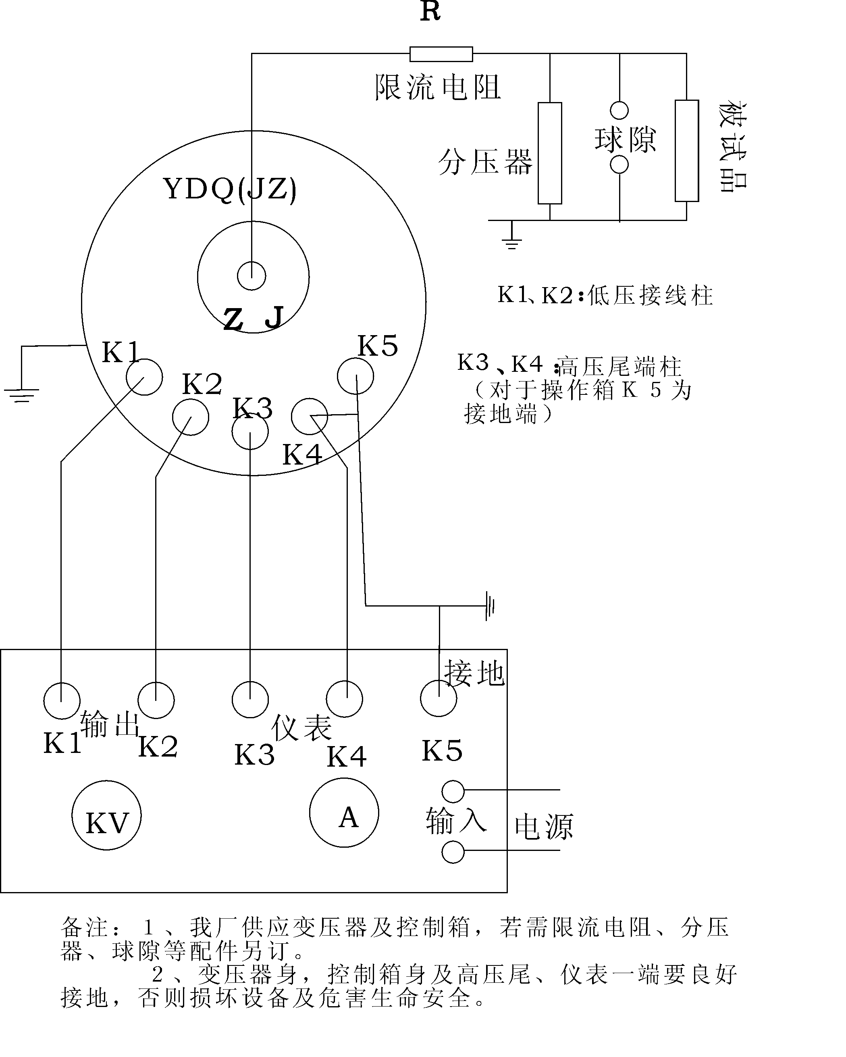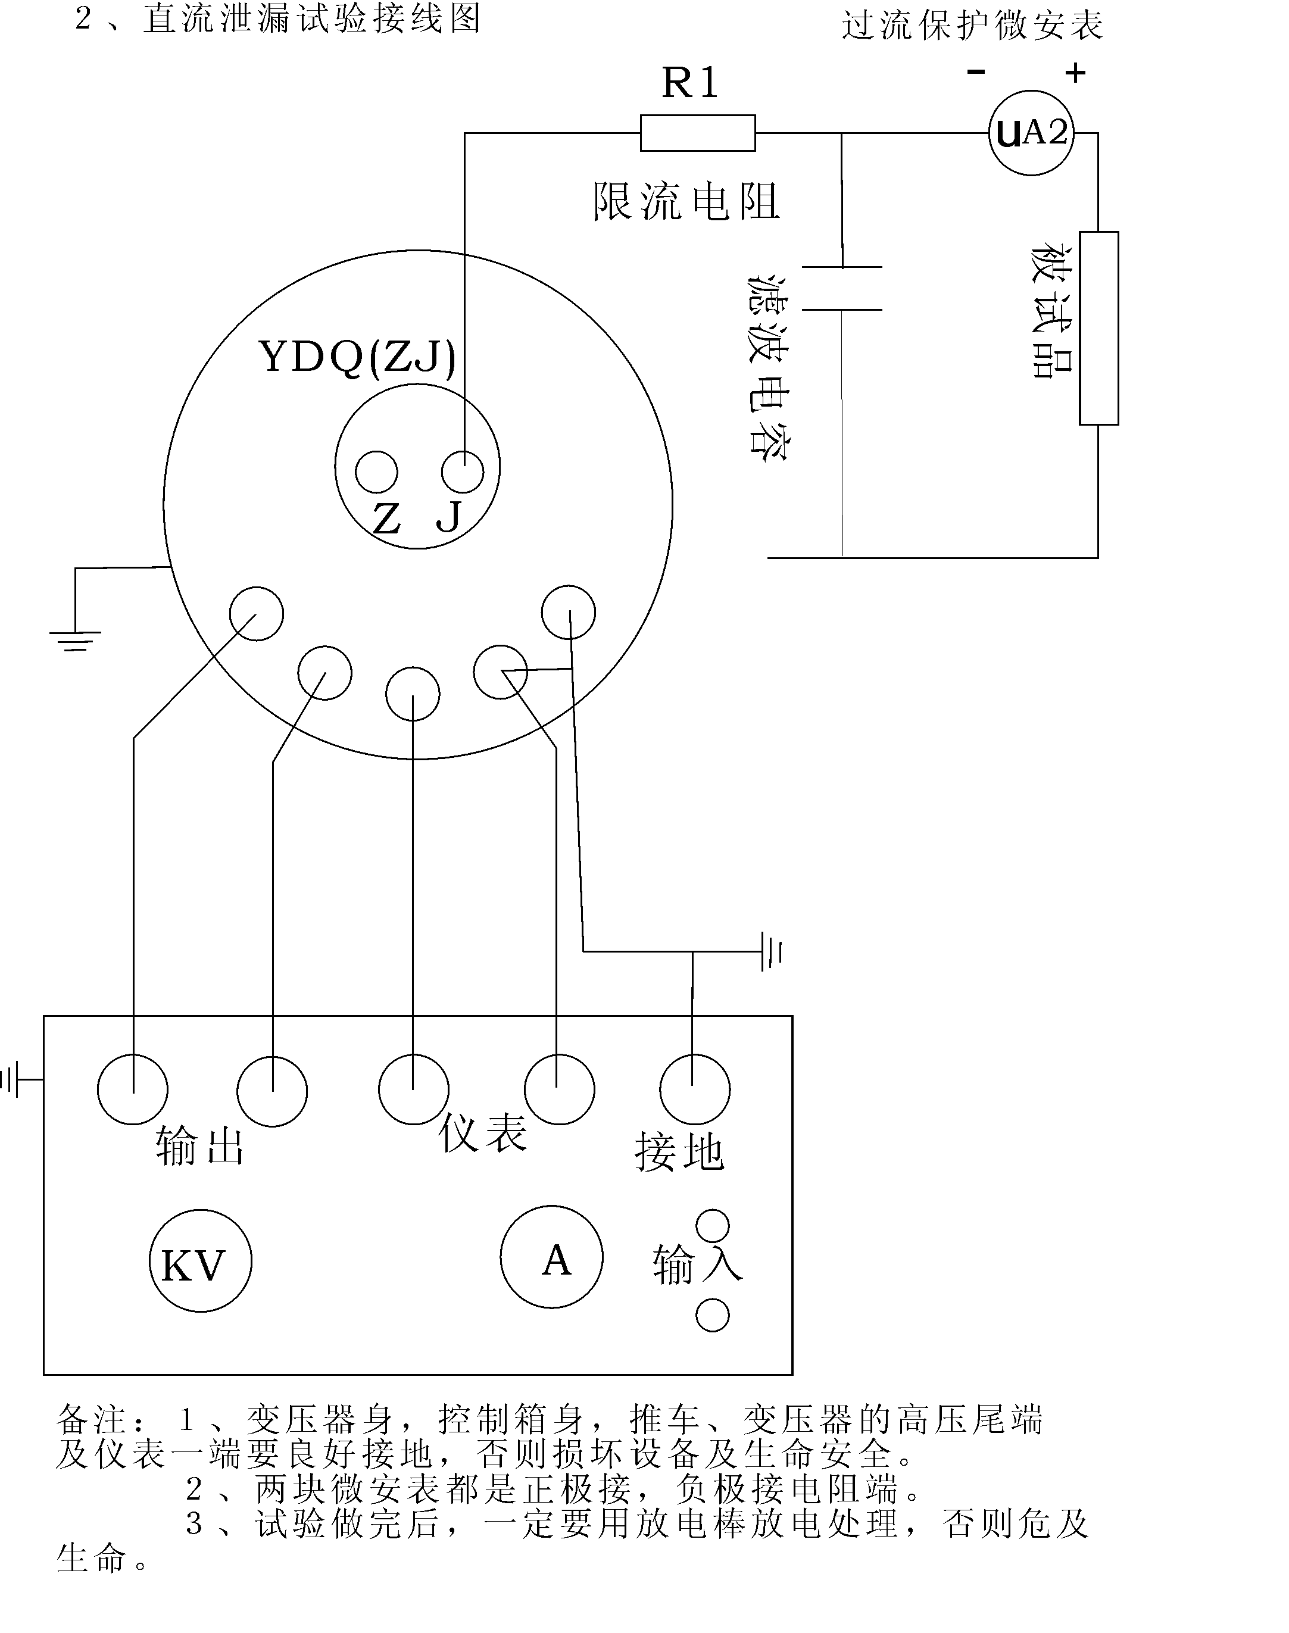
- YDQ (C) series excitation combination test connection diagram
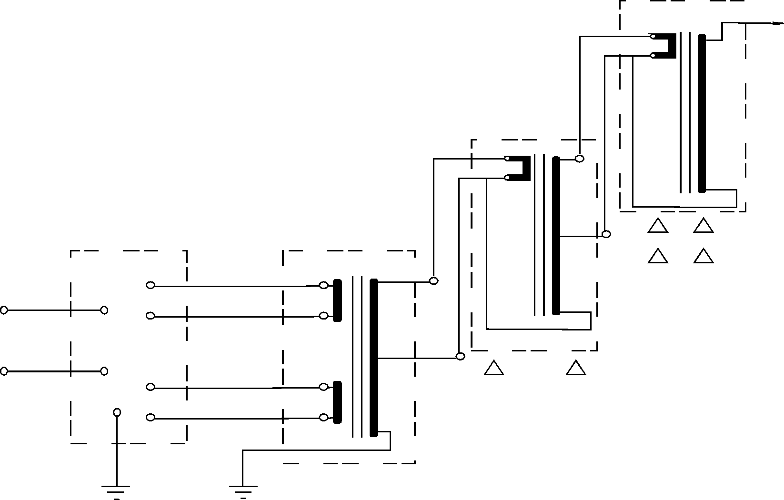
- Cascade wiring
Supporting operation box (set)
BYQQ (C) - Ⅰ - First group trial transformation; BYQ (C) - Ⅱ - Second group trial transformation
BYQ (C) - Ⅲ - Third group trial transformation; △ - Insulation bracket
Note: The serial connection wire must be wired in the direction indicated on the wiring label, otherwise the polarity is reversed.
- Overview
In order to facilitate on-site level testing of the power system, we have specifically designed and produced multiple lightweight test transformers in series with BYQ (C) series testing equipment. Due to the convenient use of dispersed combination ability, it can adapt to various on-site needs. Each unit is lightweight, easy to transport and move, allowing for smooth access to high test power sources on site.
- working principle
The BYQ (C) series high-voltage test device, except for the highest voltage level, has excitation groups wound in series in the high-voltage winding. The parameters of this winding are the same as those of the primary coil of the subsequent test transformer.
The power supply for the winding of the first level test transformer is provided by the control panel (box). The tail end of the first level high-voltage winding is grounded to the shell, and the head end is connected to the high-voltage tail and shell of the second level test transformer. The excitation power supply for the low-voltage winding of the second stage is supplied by the first stage series excitation tap. At this time, the output of the second stage test transformer is the superposition of the first and second stage outputs. Similarly, the third level can be stacked.

- Operation test method
1. Connect the wires as shown in the diagram and check if the internal gas pressure indicated by the pressure gauge is normal (≥ 0.3MPA)
2. Insert the short-circuit rod into hole J during AC withstand voltage testing, conduct a DC leakage test, and remove the short-circuit rod.
3. Current limiting resistor configuration: Power frequency withstand voltage of 0.3-1 ohms per volt, DC withstand voltage of 5-10 ohms per volt, generally not required for testing.
4. Remove the lead wires, sleeves, and body dirt of the test sample, and use shielding measures if necessary.
5. The preparation work and safety measures are ready, and the equipment will be air tested once.
6. Connect the test sample and use shielded wires for DC testing to eliminate stray leaks.
7. Turn on the power, and the power indicator light and zero position indicator light on the console (box) will light up,.
8. Press the start button, and the start indicator light will turn on.
9. Rotate the regulator handwheel evenly and slowly clockwise, observe the reading on the voltmeter, and stop rotating the regulator handwheel when it reaches the rated voltage value.
10. Pay close attention to the ammeter indication and withstand voltage time.
11. When the pressure resistance time is up, the regulator handwheel should be promptly and uniformly rotated in reverse until the regulator returns to zero position.
12. After conducting the experiment shown in Figure 2, discharge through a resistor using a discharge rod, and then discharge directly to the ground.
13. The high-voltage part may be discharged one by one by the charging parts, and the high-voltage leads may be changed or removed
14. The experiment is completed.
- Precautions

1. The layout of experimental equipment should have sufficient safety distance around people. Try to avoid placing equipment and high-voltage leads in personnel corridors as much as possible.
2. Install fences and hang "Stop, High Voltage Danger" signs at the test site.
3. High voltage leads in the experiment should have supporting or traction insulation materials. There should be a safety supervisor to prevent anyone from approaching or passing underneath.
4. It is best to keep the microampere meter at a high position in the DC high voltage test. In addition to the shielding box, there should be an overcurrent automatic protection device to prevent the meter from burning out in case of sudden breakdown, short circuit or discharge.
5. Power frequency withstand voltage test, pay attention to verifying whether the equipment capacity is sufficient and avoid resonance.
6. The working ground wire (high voltage tail, stabilizing capacitor terminal ground wire) and the protective ground wire (operating part casing) should be connected separately and have good grounding performance.
7. If there is irregular swinging of the power supply during the experiment (such as welding), it will inevitably affect the stability of the high-voltage output. At this time, the experiment should be stopped to find the cause and eliminate it.
8. The requirements for climate (temperature, humidity) in the experimental work should comply with the requirements of the experimental regulations and be recorded.
9. The high-voltage testing work must strictly comply with the relevant provisions of the safety work regulations issued by the Ministry of Energy.

- Maintenance and upkeep
1. The test transformer should be kept clean regularly, and the nylon sleeve should be wiped clean and covered with plastic cloth before each test.
2. Bolts other than wiring supports should not be twisted arbitrarily to prevent air leakage caused by seal failure.
3. Slight leakage is a normal phenomenon, estimated to decrease the air pressure by 0.05Mpa every 4 years, and the air pressure at the factory is between 0.4-0.5Mpa. With the change of environmental humidity, the air pressure slightly increases or decreases. When the air pressure drops to 0.3Mpa, it should be replenished promptly.
4. Please use the dedicated inflation nozzle and small canister of sulfur hexafluoride gas provided by our company when replenishing air, and the inflation pressure must not exceed 0.55Mpa. Generally, 0.4-0.5Mpa is sufficient.
5. Inflation method:
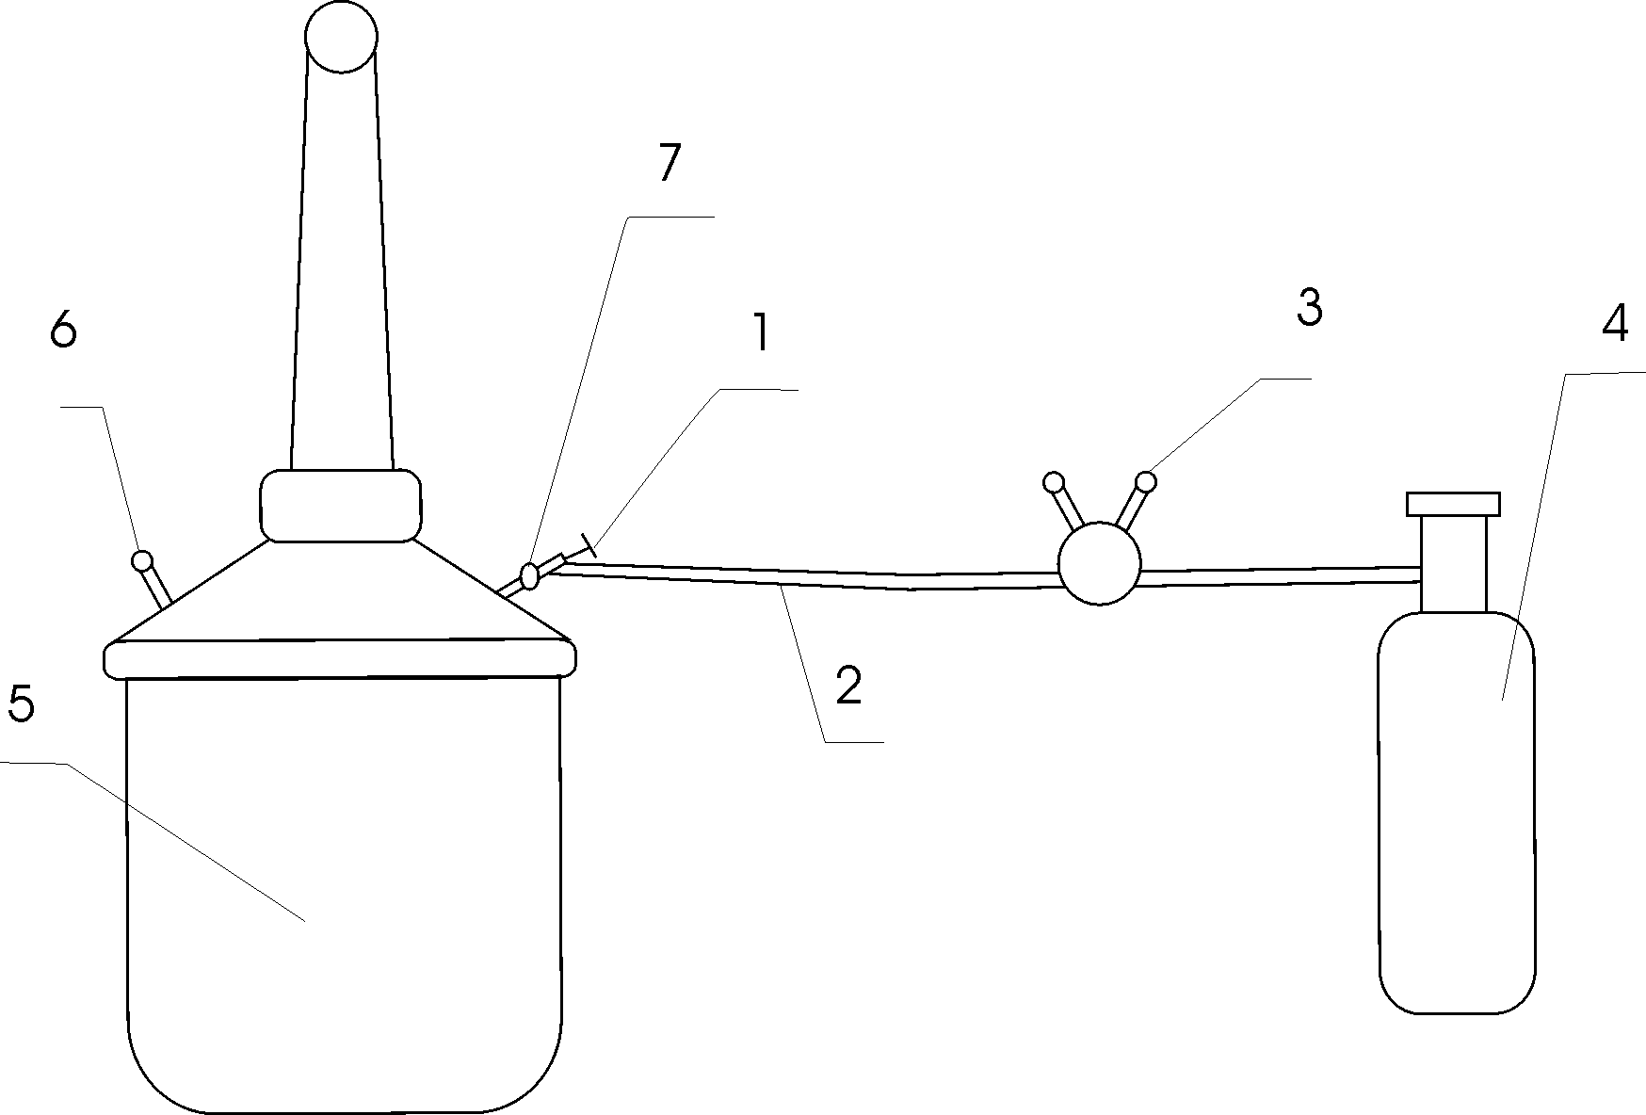

1. Inflation valve 2, oxygen pipeline 3, oxygen meter
4, sulfur hexafluoride steel cylinder
5. Transformer 6, pressure gauge 7, transformer inflation nozzle

① Connect the pipeline according to the diagram.
② Open the valve on the sulfur hexafluoride cylinder and maintain the pressure on the oxygen meter at around 20kg/cm.
③ Insert the spiral tip on the oxygen meter to gradually increase the air pressure. At this moment, gas is escaping. Exhaust the air from the pipeline.
④ Immediately open the inflation valve (clockwise direction) and hear the airflow flowing into the transformer body.
⑤ Adjust the screw tip on the oxygen meter to maintain the outlet pressure at 5.5 Kg/cm.
⑥ Monitor the transformer pressure gauge and immediately close the inflation valve (counterclockwise direction) when the pressure reaches 4.0-5Kg/cmj (i.e. 0.4-0.5Mpa). Absolutely prohibit overpressure to avoid danger.
⑦ Close the valve on the sulfur hexafluoride gas cylinder.
⑧ Close the valve on the oxygen meter to complete the inflation process.
⑨ Remove the pipeline and inflation valve, let it rest for 5 minutes after inflation, and allow the gas to mix thoroughly to start working.

- The usage conditions of the test transformer

1. Under rated operating conditions, the test transformer should meet the following requirements
A. Surrounding environment temperature: maximum temperature+40 ℃, minimum temperature -20 ℃
B. The maximum relative temperature of the air, when the air temperature is 25 ℃, the relative humidity does not exceed 85%.
C. The installation location is not a place where gases, vapors, chemical dust, dirt, or other explosive media that seriously affect the insulation of the transformer are present.
D. When using the test transformer, the input voltage should be gradually increased and sufficient protective resistors should be connected in series at the output terminal. It is important to avoid disconnecting the equipment under high voltage conditions.
2. Allowable operating time of transformer
At the rated voltage of the rated capacity, continuous operation shall not exceed half an hour, with a working time interval of 5-10 times the working time to ensure sufficient heat dissipation of the transformer. Long term continuous operation is allowed under working conditions of two-thirds of the rated voltage and current.

- Technical indicators and parameters

1. The no-load current of transformers of various voltage levels is 4-9%, and the impedance voltage is 4-10%
2. Control the existing specifications and operating time of the control part.

Model | Paired with BYQ (KVA) | Voltage regulator capacity(KVA) | Supportingoperating timemin(Min)
BYQ-2 | 1.5 | 1.5 | ≤30
BYQ-3 | 3 | 3 | ≤30
BYQ-5 | 5 | 5 | ≤30
BYQ-10 | 10 | 10 | ≤30
BYQ-20 | 20 | 20 | ≤30
BYQ-30 | 30 | 30 | ≤30
BYQ-50 | 50 | 50 | ≤30

Note: Can be matched according to user requirements

BYQ series high-voltage test transformer rated
Model | Capacity (KVA) | LV Side |  | HV Side |  | measurement  change | 6 minutes  temperature rise(℃) | impedance voltage％ | no-load current  ％ | Weight  Kg | Overall Size  LХWХH  mmХmmХmm
Model | Capacity (KVA) | Voltage  (V) | Current  (A) | Voltage  KV | Current  mA
1.5/50 | 1.5 | 200 | 7.5 | 50 | 30 | 500 | 50 | 10 | <4 | 30 | 200Х275Х640
3/50 | 3 | 200 | 15 | 50 | 60 | 500 | 50 | 10 | <4 | 35 | 240Х300Х690
5/50 | 5 | 200 | 25 | 50 | 100 | 500 | 50 | 10 | <4 | 50 | 250Х355Х710
10/50 | 10 | 200 | 50 | 50 | 200 | 500 | 50 | 10 | <4 | 60 | 260Х375Х750
15/50 | 15 | 400 | 37.5 | 50 | 300 | 500 | 50 | 8 | <4 | 70 | 270Х420Х800
20/50 | 20 | 400 | 50 | 50 | 400 | 500 | 50 | 8 | <4 | 85 | 285Х440Х820
30/50 | 30 | 400 | 75 | 50 | 600 | 500 | 50 | 8 | <4 | 100 | 295Х386Х840
50/50 | 50 | 400 | 125 | 50 | 1000 | 500 | 50 | 8 | <4 | 120 | 320Х416Х910
5/100 | 5 | 200 | 25 | 100 | 50 | 500 | 50 | 10 | <4 | 65 | 330X460X910
10/100 | 10 | 200 | 50 | 100 | 100 | 1000 | 50 | 10 | <4 | 65 | 350Х475Х1300
15/100 | 15 | 400 | 37.5 | 100 | 150 | 1000 | 50 | 8 | <4 | 85 | 510Х390Х1320
20/100 | 20 | 400 | 50 | 100 | 200 | 1000 | 50 | 8 | <4 | 100 | 540Х400Х1340
30/100 | 30 | 400 | 75 | 100 | 300 | 1000 | 50 | 8 | <4 | 110 | 560Х410Х1360
50/100 | 50 | 400 | 125 | 100 | 500 | 1000 | 50 | 8 | <4 | 125 | 600Х460Х1410
10/150 | 10 | 200 | 50 | 100 | 66.7 | 1500 | 50 | 10 | <4 | 90 | 265Х380Х1750
15/150 | 15 | 400 | 37.5 | 150 | 100 | 1500 | 50 | 8 | <4 | 100 | 510Х390Х1800
20/150 | 30 | 400 | 50 | 150 | 133.3 | 1500 | 50 | 8 | <4 | 110 | 540Х415Х1800
30/150 | 30 | 400 | 75 | 150 | 200 | 1500 | 50 | 8 | <4 | 125 | 560Х430Х1800
50/150 | 50 | 400 | 125 | 150 | 333.3 | 1500 | 50 | 8 | <4 | 140 | 640Х490Х1850

