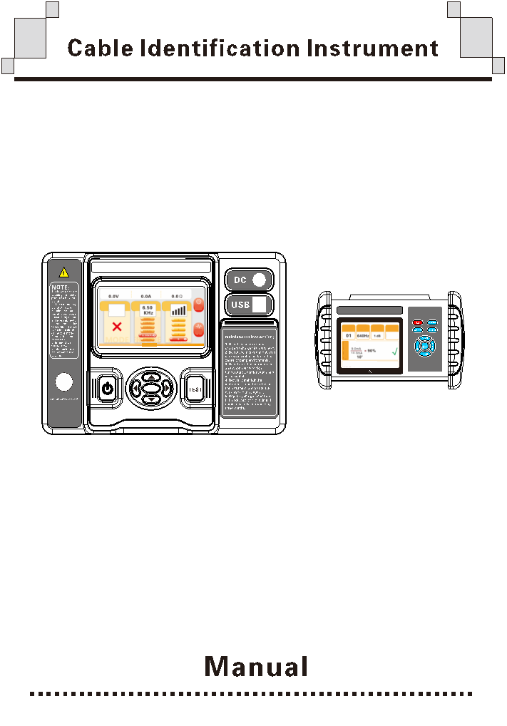

DIRECTORY
Safety instruction 1
Ⅰ.Brief introduction 2
Ⅱ.Technical specifications 3
1.Transmitter technical specification 3
2.Receiver technical specification 5
Ⅲ.Structure 7
Ⅳ.Operation 8
1.Operation note 8
2.Basic steps of cable identification 8
3.Basic transmitter operation 9
4.Basic receiver operation 9
5.Power outage cable identification 9
6.Live cable Identification 11
7.Armored damaged mode 14
8.Instrument self-inspection 15
Ⅴ.Battery management 16
Ⅵ.Packing List 17

Safety instruction
- In electricity!Danger! The operator must pass strict training and obtain the relevant national electrician operation certification to use the instrument for field testing. Note the labeled text and icon of the instrument panel and backplane.
- The operator must fully understand the manual instructions and can skillfully operate the instrument before conducting field testing.
- Before use, confirm that the instrument and accessories should be in good condition, and the insulation layer of the instrument and test line should not be damaged, exposed and broken.
- Pay attention to the measuring range and operating environment specified in this instrument.
- It is normal to produce a noise when the coupling clamp emits a signal.
- When the coupling clamp will generate a large magnetic suction. At this time, the clamp can not be opened only by closing the power supply of the transmitter.
- When using the direct connection output mode, do not connect the red and black test line to the running cable.
- In order to ensure personal safety, for the determined cable, before repairing the saw, must be nail test.
- Determine that the connection plug for the wire is tightly inserted into the interface.
- Do not use the instrument in wet condition.
- No testing in inflammable and dangerous places.
- The test line must be removed from the instrument only after the tested wire. The output socket should not be touched to avoid electric shock.
- Do not use it in a strong electromagnetic environment to avoid affecting the normal operation of the instrument.
- If the casing or test line is broken, please stop using it.
- Do not place and store instruments for a long time in high temperature, humidity and condensation places and direct sunlight.
- It is recommended to maintain the instruments regularly, keep them clean, and do not wipe them with corrosive agent and rough material.
- No instrument for a long time, please charge the battery regularly.
- For a battery replacement, please contact the manufacturer.
- The use, disassembly, calibration and maintenance of this instrument must be operated by authorized personnel.
- Due to the reason of this instrument, if the continued use will bring danger, it shall be stopped immediately and sealed immediately and handled by the authorized agency.
- Instrument and manual on the“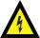” danger sign ，Users must perform safe safely as instructions.

Ⅰ.Brief introduction
Intelligent live cable identification instrument, also known as cable identification instrument, multi-function cable identification instrument, intelligent cable identification instrument, is designed for power cable engineers and cable workers to solve the technical problems of cable identification.The user accurately identifies one of the target cables from multiple cables through the instrument to avoid mistakenly sawing live cables and causing serious accidents. Cable identification starts from the operation of both ends of the cable, and the double number at both ends of the cable must be accurate.No matter how reliable the memory of the field staff is, it cannot replace the recognition of professional instruments. This product at the same time with live cable identification, outage cable identification function instrument by the transmitter, launch current clamp / launch direct test clip, receiver, receive flexible current clamp, etc, live cable identification, can be in the receiver calibration 20 cable, to the distal identification, greatly save engineering personnel operation time, improve the operation efficiency.
Transmitter: Live cable identification and power outage cable identification, transmit the signal to the target cable, built-in large capacity rechargeable lithium battery, automatic impedance matching, automatic protection. The host adopts 5.0-inch touch LCD to display output voltage, output current and circuit impedance (direct connection method), adopts intelligent human-machine interface design, supports touch gesture operation, and is convenient and easy to use, smooth operation and improved operation efficiency.
Live cable recognition: Also known as coupling method identification using caliper coupling to output composite pulse width frequency signal, the transmitter has six frequencies to choose from, respectively: 640Hz, 1280Hz, 2.56KHz, 3.84KHz, 6.50KHz, 8. 05 KHz, by coupling to the target cable (10kV three-core armored cable or single core cable), to the cable armor or core coupling the composite pulse width frequency signal, the composite pulse width frequency signal generates electromagnetic field around the target cable, and the receiver uses flexible current clamp to detect and identify; because the composite pulse width frequency signal is directional, the detection is also directional.
Power outage cable identification: Also known as direct connection method, using direct connection to output composite pulse width frequency signal. The transmitter has six kinds of choice, respectively, 640Hz, 1280Hz, 2.56KHz, 3.84KHz, 6.50KHz, 8.05KHz, inject composite pulse width frequency signal into the cable core. The composite pulse width frequency signal generates electromagnetic field around the target cable for detection, decoding and identification by the receiver and flexible current clamp; Since the current is directional, the detection is also directional.
Receiver: For handheld equipment, built-in high-speed microprocessor, receiver using hardware filter + DSP digital filter algorithm double filter processing, has excellent filtering performance, and the advanced FHD algorithm can filter interference frequency and the transmitter composite coding current signal extraction and decoding, combined with scientific rigorous calibration rules, greatly reduce the field personnel use requirements, LCD directly display correct detection results, cable identification success shows √, be clear at a glance, easy to use, can calibrate 20 cables at the same time, not repeat calibration, improve work efficiency.
Special note: The cable identification instrument also has the function of live cable identification and power failure cable identification. When the power outage cable identification, it is strictly prohibited to access the running cable. When identifying, the transmitting clamp and the receiving clamp should not be mixed, and the direction of the input signal should be consistent.

Ⅱ.Technical specifications

1.Transmitter technical specification
Function | Output composite pulse width frequency signal, signal coupling output, signal directly connected output, display output voltage, output current, circuit impedance, residual battery voltage, and dynamic indication of transmission state
Power supply | Live identification model: 9.6V / 6Ah lithium battery, full power continuous operation for about 8 hours (3 levels output)
Output method | Live identification model: automatic identification, caliper coupling during live identification; direct connection output during power identification  Power outage identification type: only power outage identification direct connection output
Frequency | 6 Adjustable：640Hz、1.28KHz、2.56KHz、3.84KHz，6.50KHz，8.05KHz
Output interface | Waterproof aviation socket
Output power | Maximum 15W, 5 Levels adjustable, automatic real-time impedance matching
Output voltage | The maximum peak value is about：110V
Armored damaged mode | Yes
Transmitter clamp | inner diameter：φ125mm wire length：3meter
Directed connection clamp | Caliber：Max 24mm wire length：1meter
Transmitter clamp magnetically saturated | 40A（50Hz）
Human-computer interaction | Physical buttons, touch screen , gesture recognition
Auto shut off | Yes, no operation, no output for 30 minutes of automatic shutdown, the time can be set
Automatic standby | Yes, the default no operation for 5 minutes to automatically reduce the screen brightness to save power, the time can be set
External voltage detection | Yes, up to 150V
Charging port | Circular charging interface, DC mark
Fixed parts update | Support, is updated via USB
Transmitter size | 275mm×226mm×150mm
LCD size | Length width 120mm×70mm； Display field 110mm×62mm
Working temperature | -10℃～40℃
storage condition | -20℃~50℃，≤95％RH, no condensation
Working temperature | -10℃～40℃
Storage condition | -20℃~50℃，≤95％RH, no condensation
Instrument quality | Transmitter about 2.28kg; Transmitter clamp about 1.12kg; The direct connection test clip is about 170g, and the total mass is about 4.44kg
Withstand voltage | AC 3700V/rms(Before the top surface and bottom surface of the instrument box)
Electromagnetic characteristics | IEC61326(EMC)
Refer to safety regulations | IEC61010-1(CAT Ⅲ 300V、CAT IV 150V、class of pollution 2)

2.Receiver technical specification

Function | Live cable identification, power outage cable identification, single-core cable identification, with FHD algorithm
Power supply | 8.4V/2500mAhCharable lithium battery, USB charging interface, full power continuous operation for about 6 hours
Receive frequency | 6 options：640Hz、1.28KHz、2.56KHz、3.84KHz，6.50KHz，8.05KHz
Gain | 4 levels
Unique identification | Yes, the target cable display（√）
Filter mode | Hardware filtering + DSP digital filtering
FHD algorithm | Support, instrument direct results, greatly reduce the use requirements of field personnel
Calibration quantity | Number of calibrated cables: 1~20
Identification condition | Current, the percentage of the received and transmitted signal between 70% and 130% of the calibration value is one of the conditions for successful identification
Identification condition | Signal coding, receiver decoding by the algorithm, and the transmitter output coding is one of the successful identification conditions
Identification condition | Signal phase, the receiver extracts the phase through the algorithm, <50 is one of the successful conditions
Identification condition | Current direction, the receiver judges the current signal direction, and the calibration value comparison is one of the successful identification pieces
Display mode | The 3.5-inch real color LCD screen display, color icon indication
Receiver size | 172mm ×106mm ×42mm
Flexible current clamp | Internal diameter ：φ200mm Signal line length: 3 m
Scope of detection | Power failure identification: the coil can detect the composite pulse width frequency signal with circuit resistance of 0 Ω ~ 30 kΩ; generally, the cable length can be over 20 km, mainly determined by the cable grounding resistance and cable resistance.
Scope of detection | Live identification: the coil can detect the pulse signal with circuit resistance 0 Ω ~500 Ω; when the test circuit resistance is 500 Ω, the cable length can reach 0-10 km
capacity of resisting disturbance | Highest 100A（50Hz，10dB level）
Signal sampling rate | Adaptation for different frequency sampling rates，Max 819.2KHz
Armored damaged mode | Yes
The results show the period | About 2times/second
Auto shut off | After 30 minutes of no operation and no input, the instrument will be shut down automatically to save power
Auto shut off | When the battery level is too low, the instrument will be shut down
Firmware update | Support, is updated via USB
USB | USB Charging port
Working temperature and humidity | -10℃～40℃；less than 80%Rh
Store temperature and humidity | -10℃~50℃，≤95％RH, no condensation
Receiver quality | Flexible current clamp 112g; Receiver 405g (with battery)
Withstand voltage | AC2000V/rms(Before the front and rear ends of the enclosure)

Ⅲ.Structure

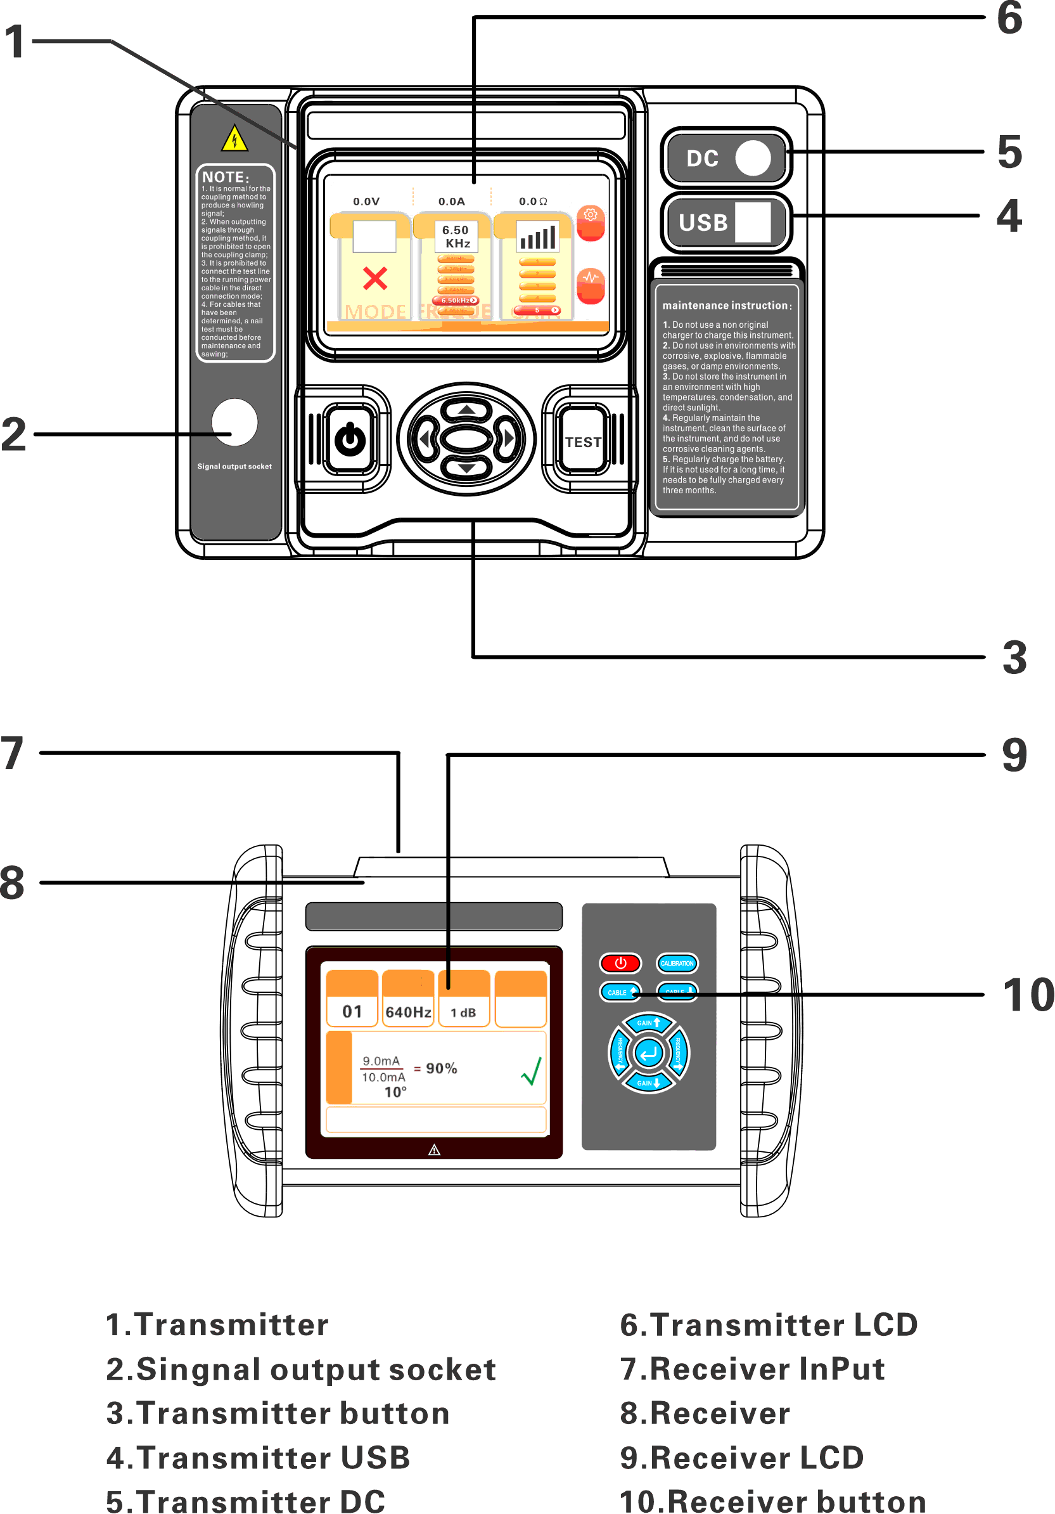

Ⅳ.Operation

1.Operation note
● Electricity, danger! The instrument must be operated by trained and authorized personnel, and the operator must strictly follow the safety rules, otherwise there is a danger of electric shock, causing personal injury or equipment damage.
● Cable identification involves personal and safety of facilities, which must be excluded based on the results of various field information (such as cable diameter, etc.) given by the instrument. The rest should be fully analyzed to determine the difference between the current size and direction of each parallel cable, and finally make a judgment.
● Cable identification: Please confirm that the arrow on the flexible current clamp points to the distal end of the cable (the end where the cable core is grounded), that is, the positive input end of the composite wave signal.
● When identifying the live cable, the flexible current clamp should be kept more than 1 meter from the transmitting clamp as far as possible to prevent receiving interference.
● The correct judgment of the instrument is based on the correct operation. Please ensure the wiring mode and the correctness of the calibration operation. After the calibration, do not change the output frequency of the instrument and the amplification multiple of receiving, otherwise it must be recalibrated.
● It is strictly prohibited to open the transmitting pliers when transmitting the signal to avoid damage to the machine. The launching pliers shall be opened and closed again after the launching machine.

2.Basic steps of cable identification
Reliable identification results are based on the correct identification steps. The basic steps of cable identification operation are as follows:
Step 1: Transmitter wiring
Step 2: Transmitter output
Step 3: Proximal cable calibration
Step 4: Cable distal end identification
Calibration meaning: Cable identification requires the receiver to first measure the current size, current direction, phase, coding information at the known position of the target cable, as the reference for comparison, to compare the measurement results at the unknown point with the reference, to make the correct or wrong identification judgment. The process of measuring and recording the current size, current direction, phase, and encoding information is the calibration.

3.Basic transmitter operation
The transmitter will short-press the power button Turn on / off.The instrument can be operated by button or touch screen, which only supports single point touch.
In the signal output interface, short press the upper and lower direction keysOr click through the touch screen or swipe the corresponding area to switch the frequency, short press the left and right direction keysOr switch the output power by clicking or sliding on the touch screen. Long-press the TEST button Or long press the touch screen to start the output button output, short press the TEST button or short press the touch screen to start the output button to stop the output。Short press ENTER to determine the buttonOr the system Settings button of the touch screen enters the Settings interface.
In the setting interface, you can pass the upper and lower direction keysOr touch the touch screen to switch the cursor, through the left and right direction keysOr the touch screen switches the value of the item where the cursor is. The parameters such as system language, automatic shutdown time, automatic standby time and screen brightness will be saved to the local memory, and short press ENTER keyOr touch the screen return button to return to the test interface.

4.Basic receiver operation
The receiver will short-press the power buttonTurn on / off.


In the test interface, short press the calibration buttonConduct the calibration, and long press the calibration buttonCalibrated data can be deleted by pressing the cable↑Or cable↓Switch current cable；Switch current cable Short press gain when current cable is uncalibrated↑Or gain↓Switch current gain，Short press frequency← Or frequency→ Switch current frequency；Unable to switch frequency and gain if the current cable is calibrated. Short press the ENTER button in this interfaceEnter the Setup interface.
In the Settings interface, short press frequency← Or frequency→ Switch the current cursor and short press the gain↑Or gain↓Switch current value。Short-press the ENTERYou can return to the test interface.

5.Power outage cable identification
Identification principle of power outage cable: the transmitter loads the specific signal on the target cable. Due to the cable power failure, you can directly use the direct connection test clip to directly connect the target cable. The receiver first records the size and direction of the transmitted signal near the transmitter position (proximal) on the target cable, and then at the cable location (distal), the receiver re-detects the signal and uses the same setting as the calibration information, which can be judged as the target cable within a certain range.
Step 1: Transmitter direct connection method output
Connect the direct connection test clamp to the transmitter, ground the pliers black end and the red terminal wiring core, and then start it up. When the transmitter is directly connected and not output, the instrument will detect the external voltage. Please note: if the external voltage exceeds 50V, the LCD prompt bar indicates that "the external voltage is too high" and the instrument will not output the signal. After confirming that the ground voltage of the target cable is in the safe range, select the appropriate output power, long press the screen to start output button or TEST button to start output, and wait for the screen prompt bar to prompt "output, calibrable" to start calibration.
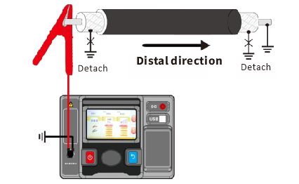
Photo 5.1 Direct connection method wiring
Step 2: Calibration
The receiver is connected to the flexible current clamp, and the flexible current clamp surrounds the red signal line in Figure 5.2.
Calibration:Select an uncalibrated cable at the test interface of the receiver, adjust the frequency to be consistent with the frequency of the transmitter, and adjust the gain to make the signal volume as large and unsaturated as possible. Wait for the signal stability, short press the calibration button pop up calibration confirmation box, and ENTER button confirm calibration, prompt calibration success, the screen will prompt "calibration success", then the receiver screen will display the target cable and display green hook, screen prompt bar prompt "signal forward", and a "tick" recognition success. If there is no above prompt, it is necessary to re-calibrate. If the signal volume is always weak, please check whether the receiver frequency is consistent with the transmitter output frequency, increase the receiver gain or increase the transmitter output frequency. If the above measures are not effective, please check the grounding of the cable.
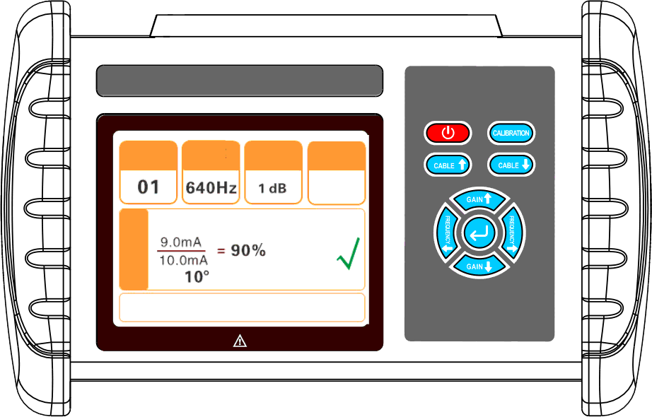
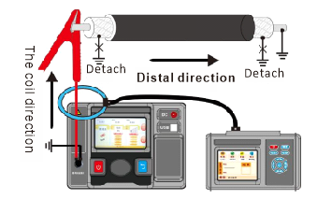
Photo 5.2 Schematic diagram of identification and calibration of blackout cable
Step 3: Identify
Cable has been calibrated, the transmitter do not shut down or stop output, to identify the distal end, the flexible current clamp around the cable, pay attention to the coil direction to the cable, in turn to identify all cable, when the cable for the target cable, the receiver screen prompt target cable, green tick, prompt signal forward, signal current range between 70%~130%, phase within the range of 0~50, and a "beep" prompt. It should be noted that the identification result is only reliable when the only target cable is obtained, otherwise it should not be performed as a reliable result.

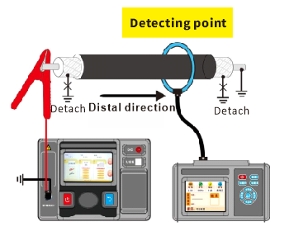

Photo 5.3 Schematic diagram of power outage cable identification

6.Live cable Identification
Identification principle of live cable: the transmitter also needs to load the specific signal to the target cable. Because the cable is charged, it cannot directly load the signal to the target cable. It is necessary to use the coupling clamp to couple the signal to the target cable without contact. The receiver first records the size and direction of the transmitted signal near the transmitter position (proximal end) on the target cable, and then at the cable location (distal end), the receiver re-detects the signal and uses the same setting as in the calibration information, which can be judged as the target cable within a certain range.
Because the live cable has high voltage, so the transmitter can not use the direct connection method to output, can only use the coupling method.

Step 1: Transmitter coupling method output
The transmitter can output according to the coupling method, and wait for the transmitter screen prompt bar to prompt "output, calibration".
Note: When the cable load current is greater than 40A, it will lead to the magnetic satiety of the coupling clamp, causing signal distortion and affecting the accuracy of the identification result.

Step 2: Calibration
The receiver connects the flexible current clamp, the flexible current clamp circles the target cable more than 1 meter from the transmitter clamp, and then select an uncalibrated cable, adjust the frequency to be consistent with the transmitter frequency, and adjust the gain to make the signal volume as large and unsaturated as possible. After waiting for the signal stability, short press the calibration button pop up calibration confirmation box, and short press frequency and frequency and ENTER button confirm calibration, successful calibration, prompt, the screen will prompt "calibration success", then the receiver screen will display the target cable and display green hook, screen prompt bar prompt "signal forward", and a "tick" recognition. If there is no above prompt, it is necessary to re-calibrate. If the signal volume is always weak, please check whether the receiver frequency is consistent with the transmitter output frequency, increase the receiver gain or increase the transmitter output frequency. If the above measures are not effective, please check the grounding of the cable.

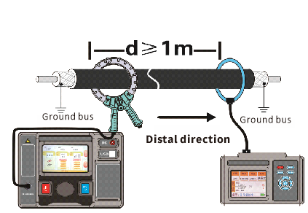
Photo 6.1 Schematic diagram of the coupling method calibration

Step 3: Identify
Live cable identification method is consistent with the blackout cable identification,
please refer to Step 3 of Section 5.
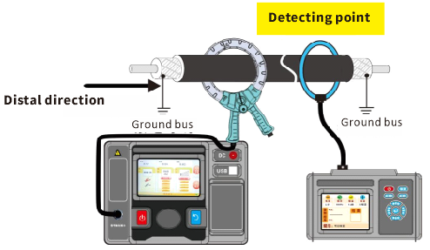
Photo 6.2 Schematic diagram of coupling method identification
Note | Identification all cables one by one at distal identification. No matter the live cable identification or the power outage cable identification, the identification result will be unique. If there are two checked cables, please refer to the common problems in the manual to analyze and check the error.

7.Armored damaged mode
Using the coupling method can normal calibration but not in the distal identification results, if the distal current direction is positive, current above 15%, can try to use armor damage pattern recognition, this mode is generally used for directly buried cable and cable through the puddle or soil moisture temperature, damaged point and direct contact with the earth form low grounding resistance, leakage from armored damage signal through the earth signal loop, cause the remote identification signal strength in the instrument.

Step 1: transmitter armor damaged mode output
After the transmitter is started, enter the Settings interface, use the button or touch screen to select the armor damage mode option and open the armor damage mode, then return to the output interface, select the appropriate output power, and use the coupling method to output. Pay attention to the transmitter clamp mode pointing to the far end of the cable.
Note: Armor breakage mode only supports the frequency between 3.84kHz~8.05kHz.
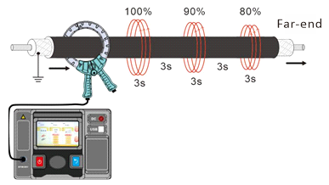
Photo 7.1 Signal Output of armored damage mode
Step 2: Calibration
The armored damage mode is generally applicable to the coupling method. The transmitter chooses the armored damage mode output, and the output power is recommended to choose the maximum power output to obtain the maximum signal volume. When the transmitter screen prompt "is output can calibration", the receiver connects the flexible current clamp, the flexible current clamp from 1 m above around the target cable, and then select a calibration cable, the frequency is consistent with the transmitter frequency, adjust the gain makes the maximum signal as large as possible but unsaturated, observed the signal changes back and forth and the maximum signal≥4.0mA。Then press the calibration button and confirm the calibration, wait for a few seconds, prompt calibration can be successful.

Step 3: Identify
Identification in armor damage mode does not directly show the identification result, only the signal direction and signal percentage.
At the far end of the cable to be identified, the direction of the flexible current clamp of the receiver needs to be calibrated in the same direction (pointing to the far end). Each identification needs to be observed for a period of time, and all the cables need to be identified in turn. If the signal of a cable is observed to be positive, and the signal amount is the largest among all the cables, then the probability of this cable is the largest. However, this method can only be used as a judgment, not as a reliable result. Before the real cutting operation, it is necessary to carry out a power outage cable identification to ensure the reliability of the results and prevent the occurrence of dangerous situations.

8.Instrument self-inspection
An instrument self-test is recommended to improve operation reliability and safety.

8.1 Live identification self-test
Using a end-to-end form loop wire as an analog cable, the transmitter using the coupling method for the cable loading signal, pay attention to use the minimum output power, receiver flexible current clamp around the wire and away from the pliers 1 meter above, switch the minimum gain, instrument can correctly calibration and identify the instrument work correctly.

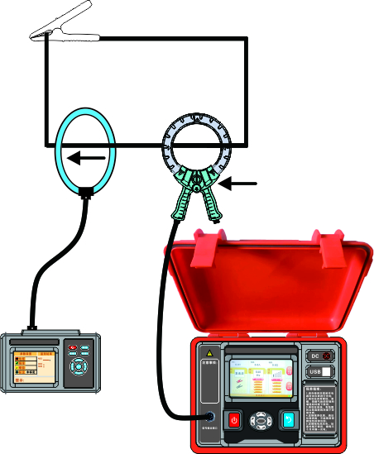
Photo 8.1 Schematic diagram of the charged self-test

8.2 Power failure identification and self-inspection
Short-circuit the red and black terminals of the transmitter directly connected test,the transmitter sets the first gear direct connection method output, and then the receiver flexible current clamp around the transmitter directly connected to the test clamp, the receiver design 1dB gain, if the receiver can correctly calibrate and identify, then represents the instrument is normal.

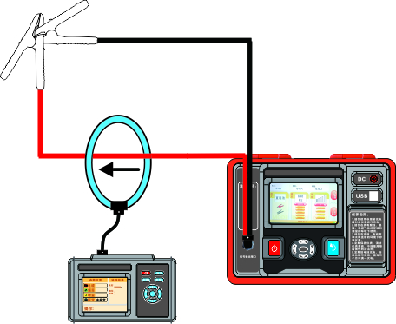

Photo 8.2 Schematic diagram of power failure self-inspection

Ⅴ.Battery management

●Charge the battery in time, and charge the battery once every 3 months without using the instrument for a long time.
1.When the battery power is low, it will affect the measurement accuracy. Please charge in time. When charging, the charger indicator light is red, and the charger indicator light turns green when fully charged.
2.Do not replace the battery and the battery charging adapter by yourself.
3.If the battery is damaged, please contact the manufacturer.
4.The transmitter will fully charge for about 4 hours
5.The receiver fully charge time is about 6 hours.

Ⅵ.Packing List

Cloth bag | 1pcs
Transmitter | 1set
Receiver | 1set
Coupling clamp | 1pcs
Directly connected clamp | 1pcs
Double-headed alligator test clip | 1pcs
Ground pile | 1pcs
Flexible current clamp | 1pcs
Charger (Transmitter) | 1pcs
Power Supply Adapter (Receiver) | 1pcs
USB cables | 2pcs(One transmitter and one receiver each)
User manual, warranty card, qualification certificate | 1set

The Company is not responsible for other losses caused by the use.
The contents of this user manual do not justify using the product for special purposes.
The Company reserves the right to modify the contents of the user manual. If modified, no further notice will be given.

